**Mini Project Report - 01**

Master of Computer Application – Data Science

Semester – I

**Sub: Front-End Frameworks and Technologies**

**Topic: RESUME**  
By  
**Name:** A.DEEPAK  
**Reg no.:** POV/ASAC.MCA/7//25/001

**Faculty Name:** VEERA RAGHAV K

**Faculty Signature: _______________**

**Department of Computer Application  
Alliance University  
Chandapura - Anekal Main Road, Anekal  
Bengaluru - 562 106**

**September 2025**

**INDEX**

1. Introduction to HTML and CSS
2. Input code
3. Output
4. Conclusion

**INTRODUCTION**

Introduction to HTML

HTML (Hyper Text Markup Language) is the backbone of all websites. It is used to structure and organize content on the web so that browsers can display text, images, videos, and links in a readable way. Instead of running calculations like a programming language, HTML works by marking up content with different tags to tell the browser what each part of the page means.

For example, you can use headings to make titles stand out, paragraphs for text, images for visuals, and links to connect one page to another. HTML works together with CSS (for styling and design) and JavaScript (for interactivity) to create complete and dynamic websites.

**Some of the most important HTML tags are:**

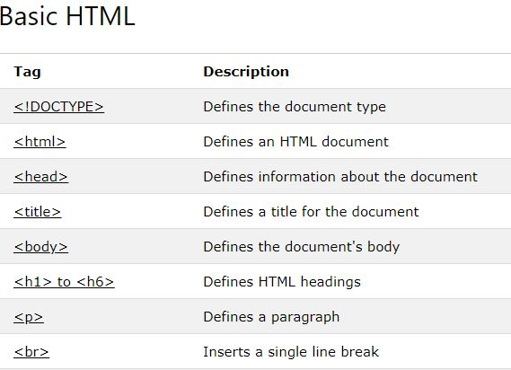

**Introduction to CSS**

CSS (Cascading Style Sheets) is the language that makes websites visually attractive and user-friendly. While HTML provides the structure of a webpage, CSS is responsible for its design—controlling colors, fonts, spacing, layouts, and even animations. With CSS, the same HTML content can be presented in completely different styles, giving web designers full creative control over how a site looks and feels.

In CSS:

• Selector → Targets the HTML element you want to style (e.g., h1).

• Property → Specifies the aspect to change (e.g., color, font-size).

• Value → Defines the exact style setting (e.g., blue, 20px).

INPUT CODE :

<html>

    <head>

        <title></title>

        <link rel= "icon" href="./team stuff.jpg">

        <style>

            h1{

               text-align: center;

            }

            div{

                border: 1px solid black;

            }

            h2{

                padding-left: 10px;

            }

            h3{

                padding-left: 10px;

            }p{

                padding-left: 20px;

            }

            span{

                color: blue;

            }

        </style>

    </head>

    <body>

        <div>

            <h1>RESUME</h1><hr>

            <h2>Name: <span>ATTEM DEEPAK MUDIRAJ</span></h2>

            <h2>Email:<span> mudirajdeepak91@gmail.com</span></h2>

            <h2>Phn: <span>+9515063522</span></h2><hr>

            <h3><u>About Me:</u></h3>

                <p>Highly motivated Data Science student with a strong foundation in Machine Learning, Applied Statistics, and Python.

                 Experienced in analyzing complex datasets, developing predictive models, and extracting actionable insights. Skilled

                 in critical thinking and problem-solving to address real-world challenges. Passionate about leveraging data-driven

                 approaches to create impactful solutions and continuously expanding expertise through hands-on projects, internships,

                 and research.</p><hr>

             <h2><u>Education Qulification</u></h2>

             <p>B.SC DS (Alliance University) 2025</p>

             <p>Intermideate(State Board)2022</p>

             <p>SSC(Telangana board)2020</p><hr>

            <h3><u>SKILLS:</u></h3>

                <ul>

                    <li>Frameworks/ Libraries:  Numpy, Panda, Seaborn</li>

                    <li>Programming Languages: Python, SQL, C, POWER BI, Machine Learning, Applied Statistic, SPSS</li>

                     <li>Developer Tools: Google Colab, Git/Github, Kaggle, Jupyter Notebook</li>

               </ul><hr>

            <h3><u>Internship:</u></h3>

            <p>Data Science Intern</p>

            <p>UNP (United Network of Professionals)</p>

             <p>• World Macro Dataset (Regression) and Insurance Dataset (Classification).</p>

             <p>• Performed data cleaning and preprocessing by handling duplicates, null values, and unique values.</p>

             <p>• Conducted Exploratory Data Analysis (EDA) to identify trends and patterns.</p>

             <p>• Applied various Machine Learning algorithms for predictive modeling.</p>

             <p>• Evaluated model performance and optimized accuracy.</p>

        </div>

    </body>

</html>

**OUTPUT:**

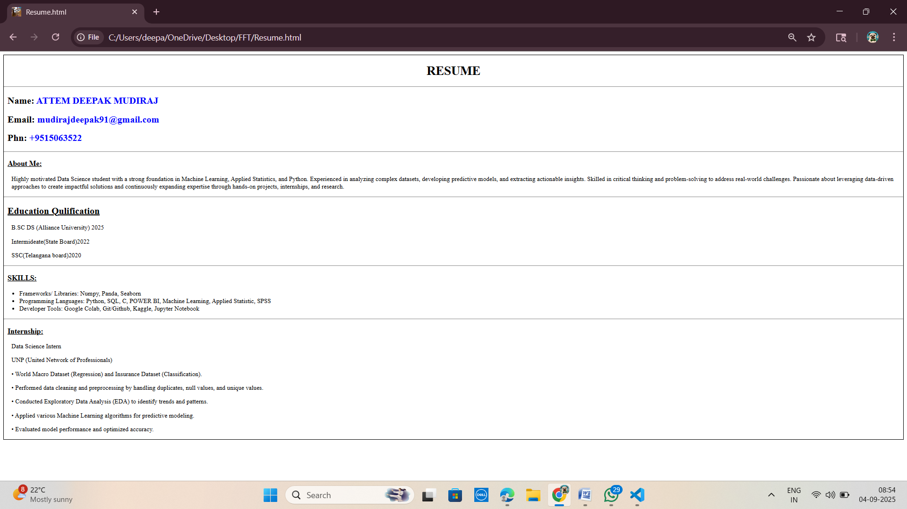

**CONCLUSION:**

This mini project highlights how combining HTML and CSS can transform plain content into a well-structured and visually appealing resume webpage. Through this project, I gained hands-on experience in organizing content with HTML and enhancing its design with CSS. While the design is simple, it demonstrates the practical use of web technologies in creating professional and presentable documents, laying a solid foundation for building more advanced web projects in the future.